Our Math Partners Rubric

Name: Date:

Mathematicians always do their best to take care of one another!
- Excellent 😊 | = Good/Okay 👍 | ✔ Not yet 💡

You | Partner | Teacher | Math partners take care of each other by...
 |  |  | listening to our partner when they’re talking 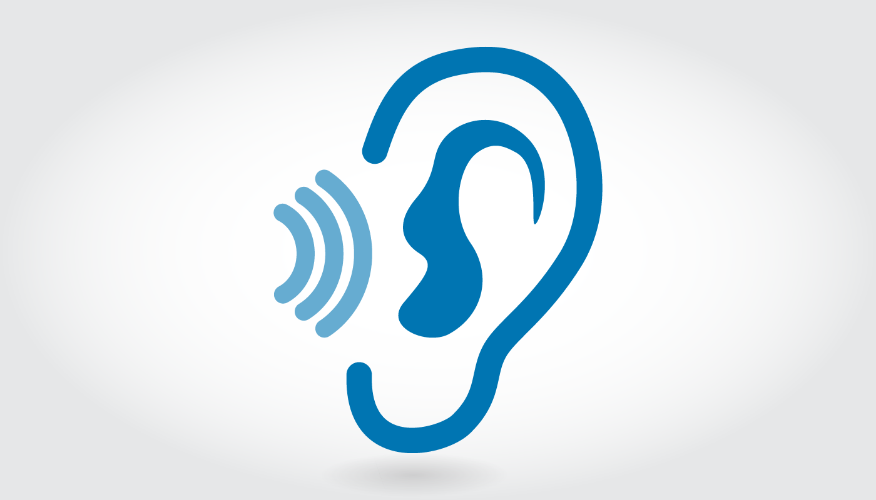
 |  |  | including our partner if they feel left out
 |  |  | sharing our thinking

