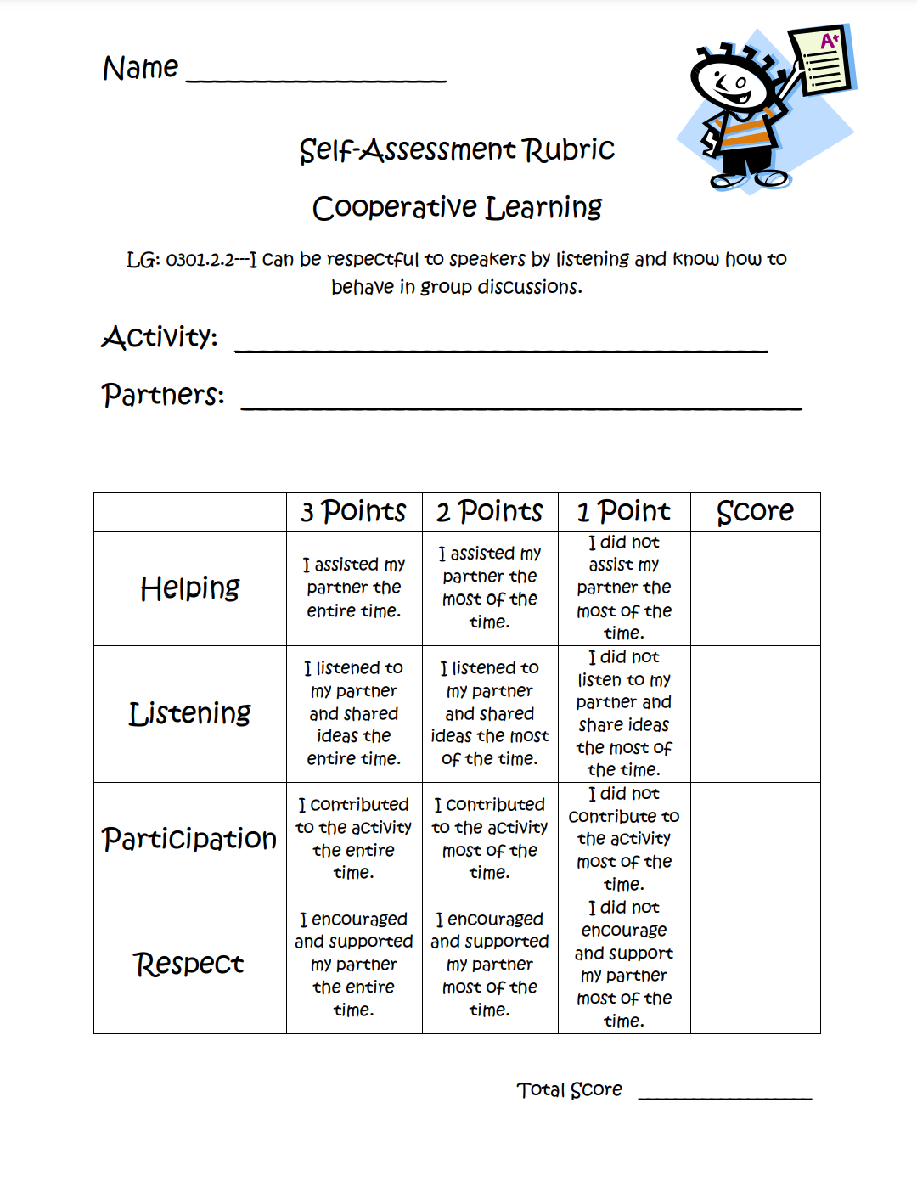

[Free on TPT](https://www.teacherspayteachers.com/FreeDownload/Cooperative-Learning-Self-Assessment-Rubric-331385)