Module 5: Early Reading
Template – Option A

Assignment:
Pull a leveled reader in the grade band that you teach, or at random if you span multiple grades. Analyze 1-3 pages of text in order to sort words into the following categories: high frequency words, words that contain only taught sound and spelling patterns and words that contain untaught sound and spelling patterns.

An example has been provided on the next page.

High Frequency Words  (words that commonly appear in texts and often taught as wholes) | Decodable Words  (words with only taught sound and spelling patterns) | Not Yet/Not Fully  Decodable Words  (words with sound and spelling patterns not yet taught)

Challenge: Highlight the taught sound and spelling patterns in the “undecodable words” column. Remember that you can often reinforce taught phonics even in these words!

Sample

Kindergarten Text:
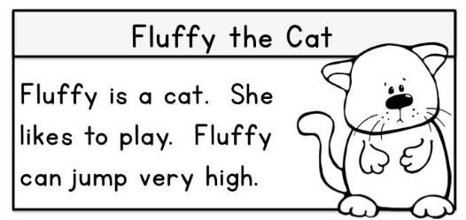

Taught phonics: Basic sound and spelling patterns for all consonants and short vowels.

High Frequency Words  (words that commonly appear in texts and often taught as wholes) | Decodable Words  (words with only taught sound and spelling patterns) | Not Yet/Not Fully  Decodable Words  (words with sound and spelling patterns not yet taught)
is  a  like(s)  to  she | can  jump  cat | play  Fluffy  very  high

Challenge: Highlight the taught sound and spelling patterns in the “Undecodable Words” column. Remember, that you can often reinforce taught phonics even in these words!

Module 5: Early Reading
Template – Option B

Assignment:
Select a text meant for use in Grades K-2. Analyze 1-3 pages of text in order to sort words into the following categories: high frequency words, words that contain only taught sound and spelling patterns and words that contain untaught sound and spelling patterns.

An example has been provided on the next page.

High Frequency Words  (words that commonly appear in texts and often taught as wholes) | Decodable Words  (words with only taught sound and spelling patterns) | Not Yet/Not Fully  Decodable Words  (words with sound and spelling patterns not yet taught)

Challenge: Highlight the taught sound and spelling patterns in the “undecodable words” column. Remember that you can often reinforce taught phonics even in these words!

Sample

Kindergarten Text:

Taught phonics: Basic sound and spelling patterns for all consonants and short vowels.

High Frequency Words  (words that commonly appear in texts and often taught as wholes) | Decodable Words  (words with only taught sound and spelling patterns) | Not Yet/Not Fully  Decodable Words  (words with sound and spelling patterns not yet taught)
is  a  like(s)  to  she | can  jump  cat | play  Fluffy  very  high

Challenge: Highlight the taught sound and spelling patterns in the “undecodable words” column. Remember that you can often reinforce taught phonics even in these words!

