Module 4: Phonics Part 2
Template – Option A

Assignment:
Collect a set of student writing (at least 6 pieces, representing the full range of abilities in your class). Evaluate each student’s spelling.

- What evidence do you see of taught sound/spelling patterns?
- Compare this to your phonics scope and sequence and/or your school’s approach to phonics. What implications are there for instruction?

Module 4: Phonics Part 2
Template – Option B

Assignment:
Evaluate each student’s spelling in the sample set (following pages). These Kindergarten students have learned the following sound and spelling patterns during phonics instruction:

- Almost all consonant sounds (excluding /j/, /x/, /y/, /w/)
- The following short vowels: /a/, /e/, /i/, /o/

What evidence do you see of taught sound/spelling patterns? What implications are there for instruction?

Sample A

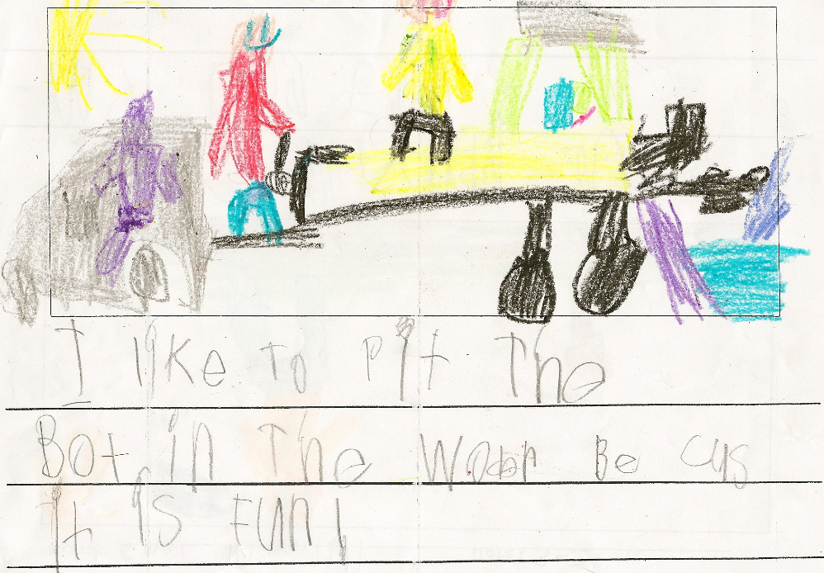
I like to put the boat in the water because it is fun.

Sample B

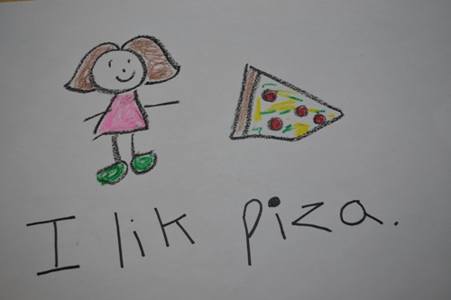
I like pizza.

Sample C

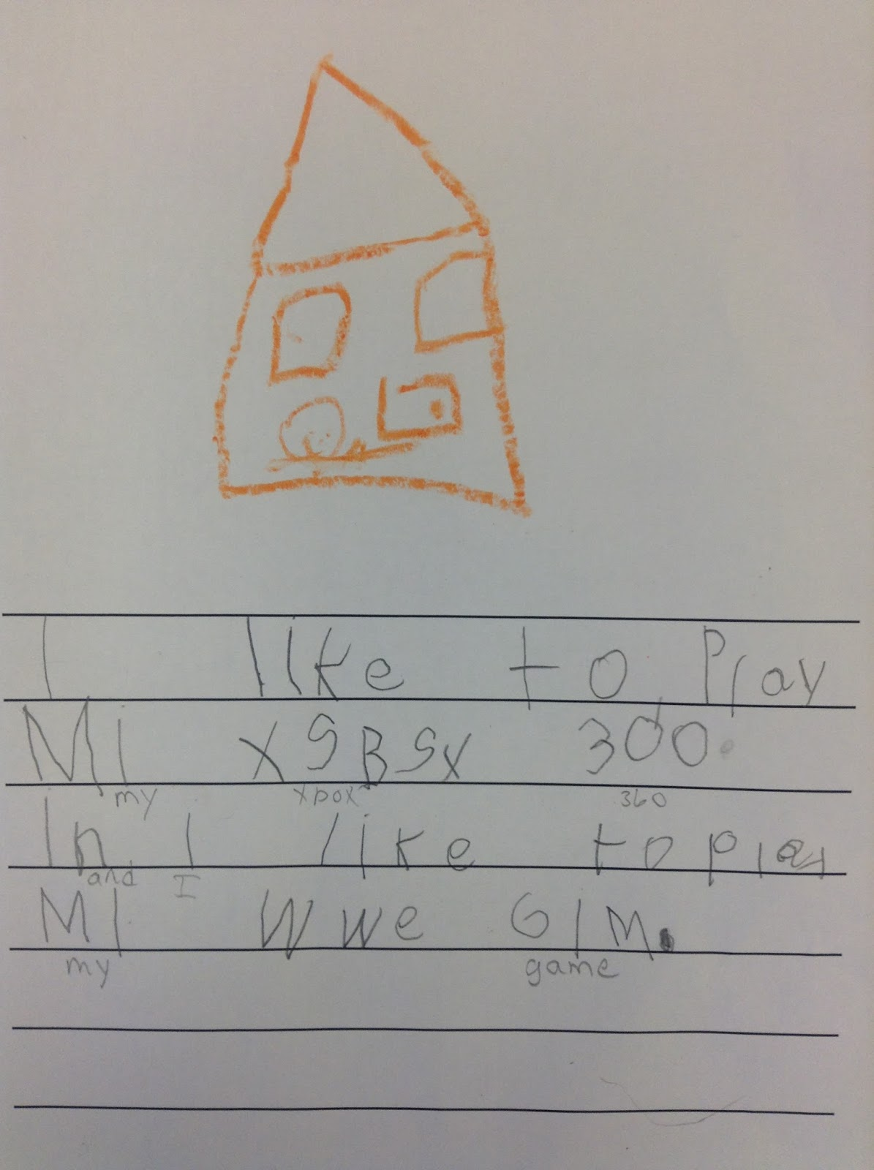
I like to play my Xbox 360 and I like to play my WWE game.

Sample D

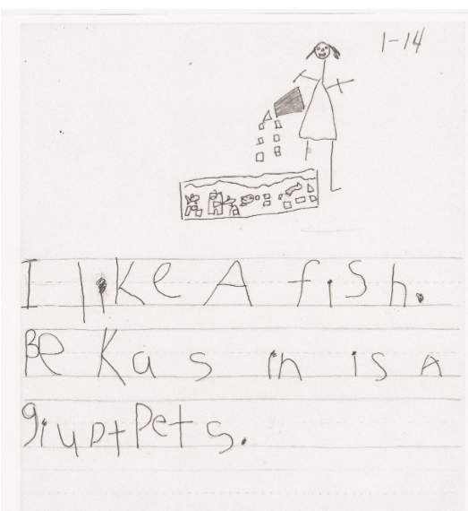
I like A fish. Because in is a great Pets.

Sample E

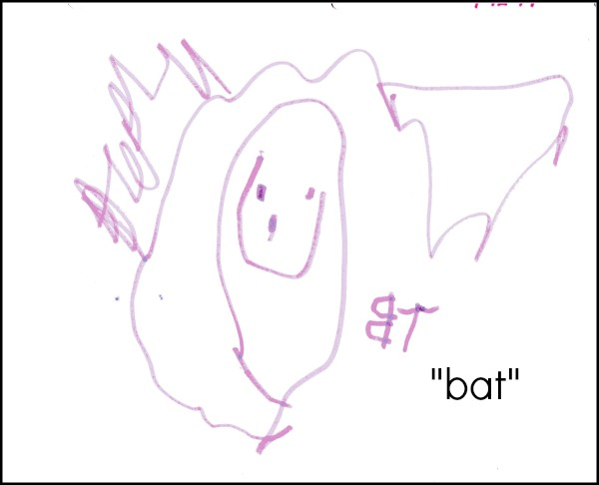
bat

