Name:

Grade 5 Date:

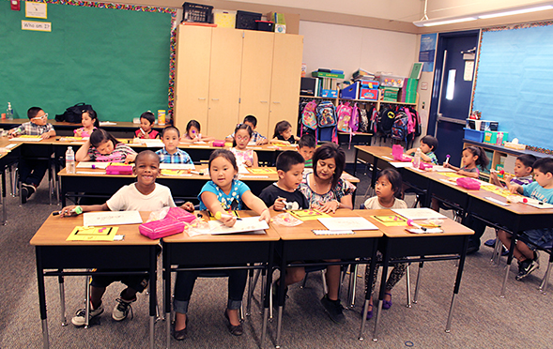
Based on the Writing for Understanding Approach, Vermont Writing Collaborative ©2011
Based on the Writing for Understanding Approach, Vermont Writing Collaborative

My Class Research Project on
How Human Activity Impacts the Environment

Research Questions:
How has human activity affected the environment?
What are individuals and communities doing to help protect the environment and the animals who live there?

Becoming an Expert
Class Research Packet
Building Knowledge and Understanding through Research

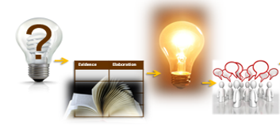

Becoming an Expert
Date Completed | Steps
 | Where Am I Going? | Text Structure
 | First Read Part 1 | Close Read Part 1
 | First Read Part 2 | Close Read Part 2
 | The Fab Five | Rolling Knowledge Journal
 | Reading for Evidence
 | Recording Evidence
 | Additional Evidence | Focus Statement
 | Working with Evidence

Research Question: How has human activity affected the environment?
What are individuals and communities doing to help protect the environment and the animals who live there?

Where Am I Going?
Work with your group to answer the questions below.

?

What is your research question?
_____________________________________________

Skim your source. In one or two sentences describe what this text is mostly about.
_______________________________________________________________________________________________________________________________________________________________

How will this source help you answer your research question?

__________________________________________________________________________________________________________

Use the copyright information for your text to complete the section below.
Title:______________________________________________

Author:____________________________________________

Type of text: nonfiction book article website excerpt other

Publisher:____________________________________________

Publication date:_______________________
Text Structure
Your teacher will lead you in exploring your source and answering the questions below.

Let’s take a look at how your source is put together.

- Leaf through the book. What patterns do you notice in how the pictures and text are arranged?

- Compare the text on the top of each page and the text in the sidebars. What do you notice about the amount of text in each place?
- What do the pictures show us about the pages that face each other?

- What is the relationship between the titles in the book and the map on the inside cover?

First Read Part 1
With your group, read the first part of the text aloud.

Use one of the options below to read pages 1-14 of the text aloud (page 1 refers to the first page of the text beginning “Frogs make our world a better place”). Check a box to show the option you chose.

Ideas for a First Read:
- Take turns reading, have each person read a page or paragraph.
- Choose one or two people to read aloud. The rest of the group reads along silently while listening.
- Listen to a recording of your book, reading along silently while you listen.
- Another idea:____________________________________

Close Read Part 1
With a partner, reread parts of your book for deeper understanding.

Work together to follow the directions in each box.
Reread the first two pages with a partner and answer the question on the right. | What context or background information does the author include about frogs in the first two pages?
Reread the text at the top of pages 3 and 4 with a partner. Then complete the activities on the right. | Which page contains the problem?  Write the problem here:  Which page contains the solution?  Write the solution here:
Reread the text in the sidebar on page 3 with a partner and answer the question on the right. | How does the information in the sidebar build on the information in the text on the top of the page?

First Read Part 2
With your group, read the second part of the text aloud.

Use one of the options below to read pages 15-29 of the text aloud. Check a box to show the option you chose.

Ideas for a First Read:
- Take turns reading, have each person read a page or paragraph.
- Choose one or two people to read aloud. The rest of the group reads along silently while listening.
- Listen to a recording of your book, reading along silently while you listen.
- Another idea:____________________________________

Close Read Part 2
With your group, read the second part of the text aloud.

Work together to follow the directions in each box.
Reread the text at the top of pages 15 and 16 with a partner and then complete the activity on the right. | Which page contains the problem?  Write the problem here:  Which page contains the solution?  Write the solution here:
Reread the text in the sidebar on page 15 with a partner and then complete the activity on the right. | How does the information in the sidebar build on the information in the text on the top of the page?
Turn and Talk with a partner about the question on the right. | What pattern do you notice?
Reread pages 25-26 with a partner and Turn and Talk about the question on the right. | Why is it important to protect frogs?

The “Fab Five”
With a partner, identify 5 important words from the text.

From your central text, choose 5 words that are important to understanding the central idea of the text.
Next use your 5 words to write about the most important idea of the text. Write one sentence for each word.

Important Word | Sentence about the Central Idea
1.

2.

3.

4.

5.

Rolling Knowledge Journal
Keep track of all you’re learning!

- After you read each resource, stop and think about what the big learning was. What did you learn that was new and important about the topic from this resource? Write, draw, or list what you learned from the text about (topic).
- Then write, draw, or list how this new resource added to what you learned from the last resource(s). Add pages if needed.

 | Write, Draw, or List
Title | New and important learning about the topic | How does this resource add to what I learned already?

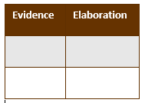
Reading for Evidence
Work as a group to gather and share information that will help you answer your research question.
Follow these steps to complete the graphic organizer together:

- First, break into groups. Assign each group a part of the text to reread and search. Record the assignments below.

Section  (page numbers) | People responsible
3-8
9-14
15-20
21-26
- As a group, look at the graphic organizer. Discuss: What is your Research Question? What kinds of information will go in each column?

- Now reread the part of the text you were assigned. When you find a part of the text that will help you answer your research question mark it with a sticky note. Use the sidebar for specific examples.

- Repeat this process until all the important information from this section has been marked.

Recording Evidence
Share what you have found with your group to complete the graphic organizer.

Focusing Question:_____________________________________

- Meet with the full group again. Take turns sharing one piece of information you found. Talk about what words or phrases to write on the graphic organizer, then fill in the appropriate row on your own organizer. You will need notes on all the information found by the group for your final project.

- Repeat this process until all the information from this source has been recorded on your graphic organizer.

Human Activity → Problem for the Frog → Solution

Additional Evidence
On your own or with a partner, add additional information to the graphic organizer.
Read one or more additional sources. Mark information that will help you answer the research question with sticky notes. Add it to your own graphic organizer. Use a different colored pencil for each source, so you will remember where your information came from.

Using the same colored pencils, list your additional sources below.

Title:
Author:
Publisher/URL:

Title:
Authors:
Publisher/URL:
--------------------------------------------------------------------------------
THE FOCUS STATEMENT!
Sum up what you have learned.
What is the “big idea”?
Look carefully at all of the evidence you have gathered. What is the “big idea” your evidence shows? Try to state what you have learned in just a sentence or two. It might even take three Your teacher and classmates will help you.

Focus Statement:______________________________________

____________________________________________________
Working with Evidence
Work with your group to better understand the information you have gathered.
EVIDENCE SORT
An activity to help you organize your evidence
Congratulations – you have collected lots of evidence to help you answer your research question! Now you are going to work together to organize the pieces of evidence you found.

Prepare for this activity by putting each human activity from the Recording Evidence graphic organizer on a separate card or sticky note.

Work as a group to sort your evidence in a way that makes sense. Begin by putting similar pieces of evidence together. Don’t be afraid to move the evidence around and try different ideas. Share your thinking - talk about what you are doing and why. Remember, you do not need to include every piece of evidence in the sort.

Once you have put the evidence in groups that make sense, add a descriptive title to each group. The title should explain why you chose to put that evidence together. Each member of your group should be prepared to explain the reasoning behind the decisions you made.

Once you have finished your sort, select two groups of evidence on which you will focus your Research Paper. Go back to your Recording Evidence graphic organizer and color code the “problem for the animal” evidence you will write about in yellow. Then color code the “solution to the problem” evidence you will write about in blue. Each group of evidence will contain both yellow (problem for the animal) and blue (solution for that problem).

Now you are ready to write!
Use your Writing Resource Packet to write an informative explanatory piece. Put the date next to each step when you complete it

Sharing Your Expertise Record Sheet
Use this record sheet with your Writing Resource Packet to deepen your understanding and communicate what you have learned.
Date | Steps
 | Learn from the Model | Write an Introduction
 | Write Proof Paragraph 1
 | Write Proof Paragraph 2
 | Write a Conclusion
 | Revise and Edit | Add a Visual
 | Share and Celebrate!

