Name:

Grade 2 Date:

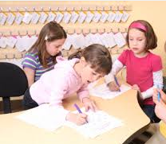

Based on the Writing for Understanding Approach, Vermont Writing Collaborative

My Group Research Project on

___________________________________

Research Question:
What kinds of living things can be found in the

___________________________ habitat?

Becoming an Expert
Group Research Packet
An expert is someone who knows a lot about a particular thing. Follow these steps to become an expert.

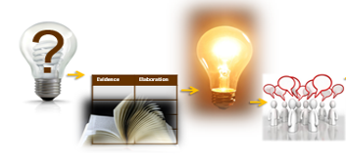

Becoming an Expert
Check each step as you finish. | Steps
 | Where Am I Going? |  | First Read
 | Reading for Evidence
 | Recording Evidence | Focus Statement
 | Working with Evidence

Where Am I Going?
Work with your group to discuss the questions below.

?
Read the research question below.
What kinds of living things can be found in the

____________________________________habitat?

Where might you find information to answer this question? Turn and share your ideas with a partner.

With your partner, look through the source your teacher has given you. Then, discuss this question:
How will this source help you answer your research question?

It is important to list the sources you use, so you can remember where you got your information. Write the title and author of your source below.

Title:______________________________________________

____________________________________________________

Author:____________________________________________

First Read
With your group, read the source aloud.

Ideas for a First Read:
- Listen carefully as your teacher reads aloud.
- Take turns reading, have each person read a sentence or paragraph.
- Choose one or two people to read aloud. The rest of the group reads along silently while listening.
- Listen to a recording of your book, reading along silently while you listen.

Optional Activities…
The “Thrilling Three”
With your group, identify 3 important words from the text.

- From your source, chose 3 words that are important to understanding the text.
- On a sheet of paper, use your 3 words to write about the most important idea of the text. Write one sentence for each word.
Important Words
1.

2.

3.

Rolling Knowledge Journal
Keep track of all you’re learning!

What did you learn that was new and important about the topic from this resource? Write, draw, or list what you learned from the text on your Rolling Knowledge Journal. Add to the journal you started with your class each time you use a new source.

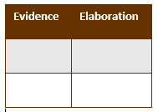
Reading for Evidence
Work as a group to gather and share information that will help you answer your research question.
- Together, look at the new public note chart that your teacher has made for your group. Discuss these questions:
What is your Research Question? What kinds of information will go in each column?

The __________________________
has a diversity of living things.

Evidence of diversity: animals or plants  Who lives here? | Elaboration: How do they live here?

- Get some sticky notes! With your group, reread part of the text. When you find some information that will help you answer your research question, mark it with a sticky note. You may want to assign each member of the group a different chapter to look in.

- Keep working until all the important information has been marked.

Recording Evidence
With your group, complete the public note chart.

- Take turns sharing one piece of information that you found. Talk about what words or pictures to put on the public notes. Fill in the appropriate row on the chart.

- Keep sharing until all the information has been recorded.

THE FOCUS STATEMENT!
What is the “big idea”?
Look carefully at all of the evidence you have gathered. What is the “big idea” that came out of your research? Turn and talk to a partner.

A focus statement tells what you have learned from your research in a single sentence. Your teacher and classmates will help you to write a focus statement below.

Focus Statement:______________________________________

____________________________________________________

More Evidence (optional)
On your own or with a partner, find more information for the public notes.

Work with a new source. Find information and mark it with sticky notes. Explain what you have found to the group and add to the public note chart.

Working with Evidence
Work with your group to better understand the information you found.

Draw and Explain

Draw:
1. Fold your paper into quarters. Label the boxes 1, 2, 3 and 4 like this:
1. | 2.
3. | 4.
2. Draw and label a sketch of one piece of evidence you learned from your source in box #1.
3. Continue to draw and label pieces of evidence in boxes 2, 3 and 4.
4. Be ready to share and explain the evidence to a partner.
5. Choose a partner in your group. It is best if your partner read a different chapter.
6. Take turns explaining the evidence you found in your reading.

Now you are ready to write!
Use your Writing Resource Packet to write about your research. Check off each step when you complete it.
Sharing Your Expertise Record Sheet

Use this record sheet with your Writing Resource Packet.
Finished | Steps
 | Learn from a Model | Write an Introduction
 | Write a Focus Statement | Write the First Piece of Evidence
 | Add More Evidence
 | Write a Conclusion | Revise/Edit
 | Share and Celebrate!

