Name:

Grade 1 Date:

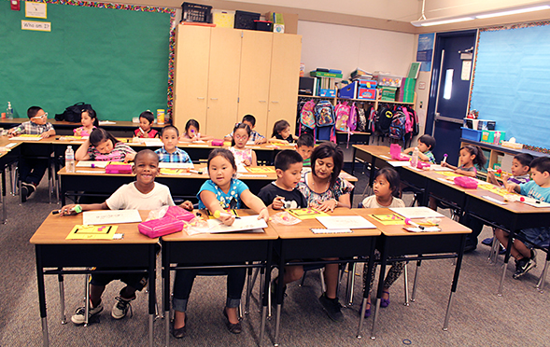
Based on the Writing for Understanding Approach, Vermont Writing Collaborative

My Class Research Project

How Adult Animals Protect Their Offspring

Research Question:

How do adult animals help their offspring to survive?

Becoming an Expert
Class Research Packet
An expert is someone who knows a lot about a particular thing. Follow these steps to become an expert.

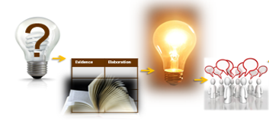
Becoming an Expert
Check each step as you finish. | Steps
 | Where Am I Going? | Text Structure
 | First Read | Close Read
 | Thrilling Three | Rolling Knowledge Journal
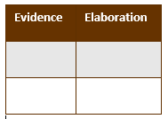 | Reading for Evidence
 | Recording Evidence
 | Focus Statement
 | Working with Evidence

?
Where Am I Going?
Work with your class to discuss the questions below.

When you do research, you study a topic to find out more information. Read the research question below to find out what you will be studying.

How do adult animals help their offspring to survive?

Where might you find information to answer this question?

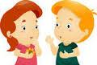Turn and talk with your partner.

A source is something we use to get information to answer the research question.
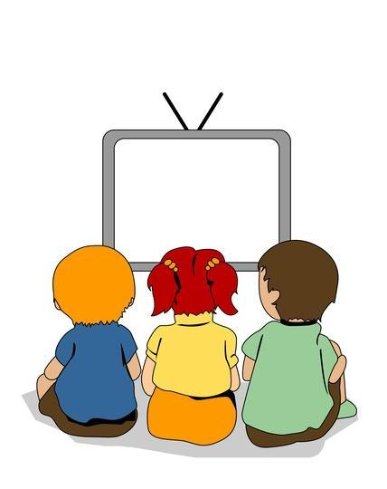
Book Video Website

A source might be a book, an article, a video or a website. With your partner:
Look through the source your teacher has given you.

How will this source help you answer your research question?

Turn and talk with your partner.

List the sources you use, so you can remember where you got your information.

Write the title and author of your source below.

Title:______________________________________________

____________________________________________________

Author:______________________________________________

____________________________________________________

Text Structure
Let’s look closely at the source to better understand how to find the information you need.

- Leaf through the pages.

- What are the chunks you notice on each page?

- Now look at another page. What chunks do you see on this page?

- Are the pages exactly the same?

- Look at another page and see what happens. Are there always three chunks of information on each page?

First Read
Listen as your teacher reads about these animals.

#6 Bass Fry Dad Takes Charge
#21 Deer Fawns Follow Their Mom
#25 Duck and Ducklings Usually Hatch on Land

Close Read
With your class, carefully reread parts of the text and answer the questions your teacher asks.

The “Thrilling Three” (optional)
With a partner, identify 3 important words from the text.

From your source, choose 3 words that are important to understanding the text.
Use your 3 words to write about the most important idea of the text.
Write one sentence for each word.

Important Words
1.

2.

3.

Rolling Knowledge Journal (optional)
Keep track of all you’re learning!

What did you learn that was new and important about the topic from this resource?
Write, draw, or list what you learned from the text about (topic).
Add to this chart each time you use a new source.
Add as many pages as you like.
Title:

New and important learning about the topic:
Title:

New and important learning about the topic:

Reading for Evidence
Work as a class to gather and share information that will help you answer your research question.

With your class, look at the public note chart that your teacher has made for the class. Discuss these questions:
What is your Research Question?
What information do you need?
Carefully, read or listen to your source again. Find information that will help you answer the research question.

Recording Evidence
With your class, add to the public note chart.

With your class, talk about what words or pictures you should put on the public notes. Your teacher will help you fill in the appropriate row on the class chart.

THE FOCUS STATEMENT!
What is the “big idea”?

A focus statement tells the big idea you have learned from your research in a single sentence.
Look carefully at all of the evidence you the class has gathered. What is the “big idea” that came out of your research?
Turn and talk to a partner.
Share your ideas with the class. Below, copy the focus statement your teacher writes on the board.
______________________________________________
______________________________________________
______________________________________________
______________________________________________

More Evidence (optional)
On your own or with a partner, find more information for the public notes.

Work with a new source. Find information about how animals protect their offspring. Explain what you have found to the class and add to the public note chart.

Working with Evidence
Work with your group to better understand the information you found.

Your teacher will lead you in a making-meaning discussion.
You will use evidence to discuss the focus question:
How do adult animals help their offspring to survive?
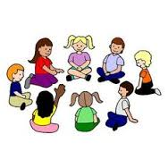
Remember to:
  - Look at the speaker
  - Quiet hands and body
  - Share and listen
  - Stay on topic

Now you are ready to write!
As a class, you will work together to write about your research. Your teacher will help you use your Writing Resource Packet to do this. Check off each step when you complete it.
Sharing Your Expertise Record Sheet

Use this record sheet with your Writing Resource Packet.
Finished | Steps
 | Learn from a Model
 | Write a Focus Statement | Write the First Piece of Evidence
 | Add More Evidence
 | Write a Conclusion | Revise/Edit
 | Share and Celebrate!

