**Name: Date:**

**Kindergarten**

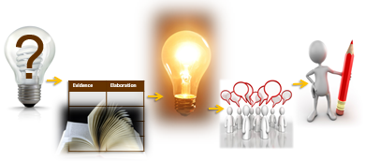

**Based on the Writing for Understanding Approach, Vermont Writing Collaborative ©2011**

**Class Research Project on**

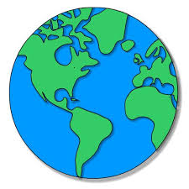Keeping our Earth Healthy

**Class Research Question**

How can I take care of the earth’s land?

**Becoming an Expert**

***Class Research Packet***

***An expert is someone who knows a lot about a particular topic. Follow these steps to become an expert.***



|  |  |
| --- | --- |
| ***Becoming an Expert***  *An expert is someone who knows a lot about a particular topic.* | |
| ✓  Done | Steps |
|  | Where am I going? |
|  | Text Structure |
|  | First Read |
|  | Close Read |
|  | Thrilling Three |
|  | Reading for Evidence |
|  | Recording Evidence |
|  | The Focus Statement |
|  | Working with Evidence |

|  |  |
| --- | --- |
|  | **Where Am I Going?**  **I can use sources to participate in a research project. (W.K.8)** |

Research Question: *How can I take care of the earth’s land?*

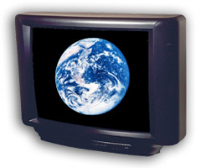

|  |  |  |
| --- | --- | --- |
|  |  |  |
| books | internet | videos |

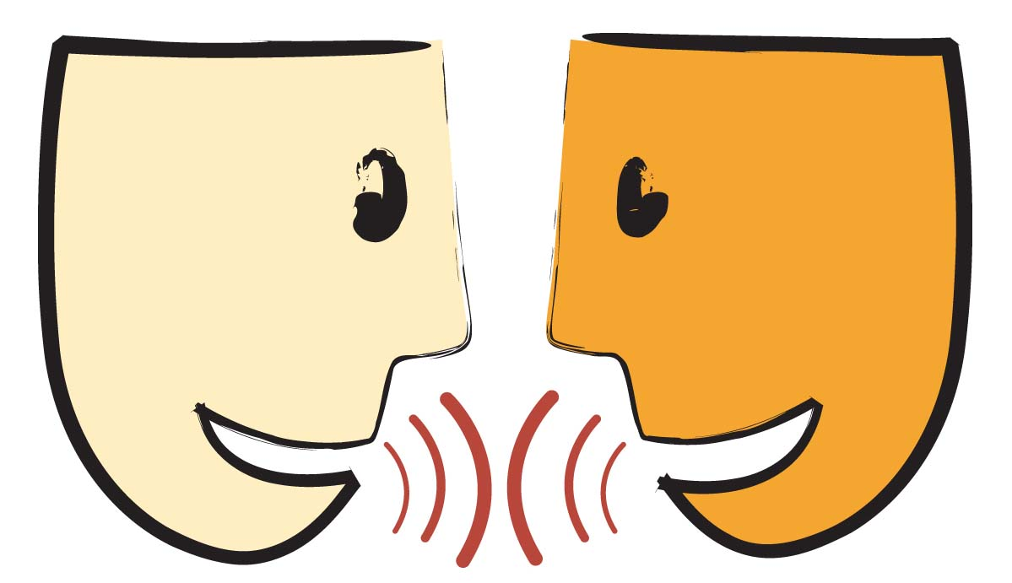Turn and Talk: How can this source help you answer your research question?

Title: _______________________________________________________________________

_______________________________________________________________________

Author:

_______________________________________________

|  |  |
| --- | --- |
|  | **Text Structure**  **I can find parts of a text. (RI.K.5)** |

|  |
| --- |
| Circle what page number a reader will find information about clean water. |
| Circle the heading on this page. |
| .  Circle the photograph.  Circle the caption.  Circle the word in **bold**. |

|  |  |
| --- | --- |
|  | **First Read**  **I can listen to a text read aloud. (RF.K.4)** |



Listen closely as your teacher reads the text aloud.

|  |  |
| --- | --- |
|  | **Close Read**  **I can answer questions about a text. (RI.K.1)** |

|  |
| --- |
| Why did the author ask: But what else can we do?  Macintosh HD:Users:trc:Desktop:talk.jpg |
| Using the photograph, what is an example of a plastic (or paper)  that can be recycled? Write your answer or draw a picture. |
| Macintosh HD:Users:trc:Desktop:talk.jpgHow is reusing an item different than recycling? |
| What are some things that can be reused? Write your answer or draw a picture. |
| Macintosh HD:Users:trc:Desktop:talk.jpgWhich item can be reused and which one can be recycled?  Circle the correct word for each picture.  Recycle or Reuse Recycle or Reuse |
| Macintosh HD:Users:trc:Desktop:talk.jpgHow is reusing food helpful to the land? |

|  |  |
| --- | --- |
|  | **Thrilling Three**  **I can use words I learned in a sentence. (L.K.6)** |

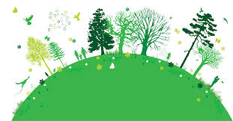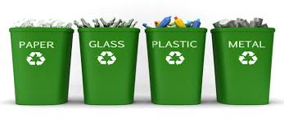What are some important words in this text?

|  |
| --- |
| Caring for our land, air, and water  _______________________________ |
| Making new things with old paper, glass, and plastic  ________________________________ |
| Use something again  ________________________________ |

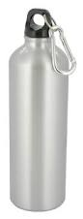

|  |  |
| --- | --- |
|  | **Reading for Evidence**  **I can gather information to answer a research question. (W.K.8)** |

Research Question: How can I take care of the earth’s land?

Look



|  |  |
| --- | --- |
| ***Idea*** | ***Examples*** |
|  |  |
|  |  |
|  |  |

Sticky note on evidence

Think and Discuss

|  |  |
| --- | --- |
|  | **Recording Evidence**  **I can record information to answer a research question. W.K.8** |



Your teacher will record the evidence on a large chart paper. It will look like the chart below.

|  |  |
| --- | --- |
|  | **The Focus Statement**  **I can answer a research question using information that I gathered. (W.K.8)** |

**Research Question**: How can I take care of the earth’s land?

Turn and talk with your partner about what you think is the ‘big idea”.

A **focus statement** tells what you have learned from your research in a single sentence.

**Focus Statement:**

_____________________________________________________________

_____________________________________________________________

|  |  |
| --- | --- |
|  | **Working with Evidence**  **I can speak in a complete sentence using ideas from my notes. (SL.K.6)**  **I can use words I learned through reading and discussions. (L.K.6)** |

Your teacher has pictures or items for you to work with. As you practice working with the evidence you will talk in complete sentences. You can use the sentence frame to help you.

**I can ___________ by _____________.**

**Now you are ready to write!**

Use your Writing Resource Packet to write about your research. Check off each step when you complete it.

