Title/Author: Cactus Hotel by Brenda Z. Guiberson
Suggested Time to Spend: 5 Days (Recommendation: One day of questions may need to be split into two sessions per day, at least 20 minutes per day)
Common Core grade-level ELA/Literacy Standards: RI.K.1; RI.K.2; RI.K.3, RI.K.4, RI.K.7, RI.K.8; RI.K.10; W.K.2; W.K.8; SL.K.1, SL.K.2; L.K.1, L.K.2, L.K.4
Next Generation Science Standards: K-ESS2-2, K-ESS3.1
K-ESS2-2: Students construct an argument supported by evidence for how plants and animals can change the environment to meet their needs
K-ESS3.1: Students use a model to represent the relationship between the needs of different plants and animals and the places they live.
Lesson Objective:
Students will listen to a literary non-fiction read aloud and use literacy skills (reading, writing, discussion and listening) to understand the central message of the book.

Teacher Instructions
Before the Lesson
- Read the Big Ideas and Key Understandings and the Synopsis below. Please do not read this to the students. This is a description to help you prepare to teach the book and be clear about what you want your children to take away from the work.
Big Ideas/Key Understandings/Focusing Question
The interdependence of living and non-living things.
How do living and non-living things depend upon one another?
Synopsis
Text and illustrations tell the story of the life cycle of the saguaro cactus focusing on how plants and animals depend on each other in a desert habitat. From the cactus seed carried on the whisker of a packrat and deposited under a Palo Verde tree, to the ultimate use of the dried cactus remains by millipedes and lizards, the text and illustrations chronicle more than a century in the life of a saguaro cactus and show how water and shelter are necessary to the survival of living things in a desert habitat.
- Go to the last page of the lesson and review “What Makes This Read-Aloud Complex.” This was created for you as part of the lesson and will give you guidance about what the lesson writers saw as the sources of complexity or key access points for this book. You will of course evaluate text complexity with your own students in mind, and make adjustments to the lesson pacing and even the suggested activities and questions.
- Read the entire book, adding your own insights to the understandings identified. Also note the stopping points for the text-inspired questions and activities. Hint: you may want to copy the questions vocabulary words and activities over onto sticky notes so they can be stuck to the right pages for each day’s questions and vocabulary work.

Note to teachers of English Language Learners (ELLs): Read Aloud Project Lessons are designed for children who cannot read yet for themselves. They are highly interactive and have many scaffolds built into the brief daily lessons to support reading comprehension. Because of this, they are filled with scaffolds that are appropriate for English Language Learners who, by definition, are developing language and learning to read (English). This read aloud text includes complex features which offer many opportunities for learning, but at the same time includes supports and structures to make the text accessible to even the youngest students.

This lesson includes features that align to best practices for supporting English Language Learners. Some of the supports you may see built into this, and /or other Read Aloud Project lessons, assist non-native speakers in the following ways:

- These lessons include embedded vocabulary scaffolds that help students acquire new vocabulary in the context of reading. They feature multi-modal ways of learning new words, including prompts for where to use visual representations, the inclusion of student-friendly definitions, built-in opportunities to use newly acquired vocabulary through discussion or activities, and featured academic vocabulary for deeper study.
- These lessons also include embedded scaffolds to help students make meaning of the text itself. It calls out opportunities for paired or small group discussion, includes recommendations for ways in which visuals, videos, and/or graphic organizers could aid in understanding, provides a mix of questions (both factual and inferential) to guide students gradually toward deeper understanding, and offers recommendations for supplementary texts to build background knowledge supporting the content in the anchor text.
- These lessons feature embedded supports to aid students in developing their overall language and communication skills by featuring scaffolds such as sentence frames for discussion and written work (more guidance available here) as well as writing opportunities (and the inclusion of graphic organizers to scaffold the writing process). These supports help students develop and use newly acquired vocabulary and text-based content knowledge.

The Lesson – Questions, Activities, and Tasks

Questions/Activities/Vocabulary/Tasks | Expected Outcome or Response (for each)
FIRST READING:  Read aloud the entire book with minimal interruptions. Spend some time on the title asking students for the definition of “hotel.” Stop to provide other word meanings or clarify only when you know the majority of your students will be confused.  ***You will need to number the pages starting with 1 on the title page opposite the copyright information. Story text begins on page 3.  Note: You may want to make sure students understand basic needs of plants and animals before continuing. | The goal here is for students to enjoy the book, both writing and pictures, and to experience it fluently as a whole. This will give them some context and sense of completion before they dive into examining the parts of the book more carefully.
SECOND READING:  p.3  Orient students to p. 2 illustration that shows multiple saguaro cacti. Explain what a saguaro cactus is.  Where did the fruit come from? How do you know?  Are there just a few or are there a lot of seeds? (If possible, have 2,000 of a small object available for them to look at.)  What is the purpose of a fruit’s seed?  Ask students to pay special attention as you read the next few pages to what happens to the seeds.  _______________________________________________  Reread p.4  What's the relationship between the pack rat and the cactus?  Prompting questions: How did the cactus help the pack rat?  p. 4 Explain skitters – Use hand motions or dramatic play to demonstrate quick light movement. What other animals would skitter? Would a mouse skitter? Would an elephant skitter? Etc.  Point out the paloverde tree.  p. 4 How does the seed get under the paloverde tree?  ____________________________________________________  Reread p. 5  p. 5 Why does the author tell us that the house finch and the ground squirrel didn't see the seed?  ___________________________________________________  Reread p. 6&7  What causes the cactus to sprout from the ground?  ____________________________________________________  Reread p. 8  When the author says, "The paloverde protects it from the hot summer sun and cold winter nights." What is “it?” And how does it protect it from the summer sun and cold winter nights? | Showing the saguaro forest is used as a preview to what will happen to the seed.  The fruit come from the cactus. The illustration helps the reader to know where the fruit came from.  The fruit has many seeds – (2,000).  The seeds are there so the plant can reproduce more plants.  ____________________________________________  He eats the juicy fruit. The rat needs the food. The tree needs the seeds to be transported and dropped somewhere.  Skitter means to move quickly without a lot of sound. Usually, smaller animals can skitter. A mouse can skitter, an elephant cannot.  The seed clings to the pack rat's whisker then falls off  ___________________________________________________  It allows the seed to stay under the tree.  ___________________________________________________  The seed was protected by the paloverde tree and watered by the rain.  ____________________________________________________  “It” is the seedling, the small cactus. In the summer it provides shade; in the winter it protects the small cactus from frost.
Reread p. 9  What depends on the rain?  p. 9 In the story the packrat scurries off, which means to hurry off with short quick steps. Consider having students act out.  ___________________________________________________  Reread p. 10  How does the jackrabbit depends on the cactus?  p. 10  Why does the rabbit run into the hole?  (Later we will discuss the significance of the jackrabbit, the hole and the coyote)  ____________________________________________________  Reread p. 12&13  On page 13 the author says, “They beckon like a welcoming signal across the desert.” What are “they?”  p. 13 What does beckon mean?  p. 13 What is important about the flowers? | “The cactus pulls in water with its long roots, the pack rat stops to drink” The rat drinks the rain water.  _______________________________________________  The cactus looks thin and uses up the water it has stored. The paloverde loses its leaves.  The jackrabbit stays cool and gnaws on the green pulp  He sees a coyote.  ____________________________________________________  They are the flowers  To summon or signal with a wave or nod. Consider acting out what beckoning looks like  The flowers provide food/nectar for birds, bees, and bats
Reread p. 14  What does it mean when the author says the fruit is "ripe and ready"?  ____________________________________________________  Reread p. 15  What is a hotel?  Reread p. 16 - 21  p. 16  How does the woodpecker make his space in the cactus?  What tool does the woodpecker use? Why do you think the author uses this word? Why doesn’t he call it a beak?  ______________________________________________  p. 17  How do the woodpecker and the cactus depend on each other?  Vocabulary note: you may need to discuss insulated and disease.  Use context clues on p. 17 to help define weatherproof  ___________________________________________________  p. 18  How does the cactus provide shelter?  ____________________________________________________  p. 21  Why are the holes important? Why are they different sizes?  Go back to p. 10 &11 Why does the jackrabbit disappear into the hole? Now that you see why the holes in the cactus are important, determine why the rabbit’s hole is important. | The flowers turn into the fruit and ripen so they can be eaten.  _________________________________________________  A place with many rooms for people to sleep in.  He taps using his beak. He bores. He digs.  The woodpecker uses his bill as a tool. He wants the reader to know that the woodpecker uses his bill for different purposes like humans use tools.  _____________________________________________  The cactus keeps the woodpecker’s nest shady on hot days and warm on frosty nights. The woodpecker eats insects that may bring disease to the cactus  ________________________________________________________  New hole for the woodpecker, a nest on an arm, an old hole for an elf owl. The birds feel safe living high up.  The holes provide shelter for many different desert animals.  ___________________________________________________  The hole provides shelter and protection from the coyote and other predators.
Reread p. 21 -27  Ask students why is the cactus like a hotel? Remind students of the definition they gave on day 1 when talking about the title.  _________________________________________________  p. 23  What happens every spring?  ___________________________________________________  p.24  How old is the cactus? What happens to the cactus? Why?  ___________________________________________________  p. 26  Who moves in to the toppled hotel?  __________________________________________________  p. 27  In what ways do these creatures still depend on the cactus even though it no longer stands?  __________________________________________________  Reread 22-27 Pay attention to the illustrations to answer this question:  How has the cactus hotel changed? Why?  Reread p. 28  (Read the first sentence again) Why does the author use the word cacti instead of cactus? (use illustration)  ___________________________________________________  THIRD READ – The purpose of this read is to have students look for evidence that there is an interdependence of living and non-living things. This will give them the content knowledge /evidence they need to do the culminating writing task.  Begin by defining Interdependence and give examples.  Tell students that you will read the book one more time, but this time they will become detectives looking for evidence that living and nonliving things are interdependent. We are going to “chunk” the text. That means stopping after each page or two to look for evidence. When you stop after each page, record student answers by putting a copy of the picture of that page on a chart paper and circling where the interdependent relationship is. In the first column put a copy of the page that shows the interdependent relationship and circle the interdependent relationship. This chart will help students when writing.  Review this chart often before asking student to do the final day writing activity. This assures that all students will have a deep understanding of the interdependent relationships. | Everybody lives there. When one animal moves out another moves in.  You might explain similes and have students practice using similes. For example: Everyone be as quiet as……  Let’s walk as slow as a ______.”  ___________________________________________________  Animals come out for a specials treat: the nectar and the juicy  red fruit.  __________________________________________________  200 years old. It crashes to the ground. It is dead so the wind blows it down.  __________________________________________________  A millipede, a scorpion, and many ants and termites  __________________________________________________  Collard lizard finds food, ground snake finds shade  __________________________________________________  Many arms grow to make more room. It falls and crumbles. It is old. It dries out.  Draw out from the students that even though the cactus is no longer a living thing, it is still very useful to the animals and insects. This would lead them up to give it as an example of interdependence during read three and is the only example of how living things can be dependent on non-living things.  There are many cactus plants. More than one cactus are cacti.  ________________________________________________  Interdependence is a big word that means two things need each other to survive. . For example: 1. All living things are dependent upon water. They need this non-living thing to live. We cannot live without water.  2. Flowers need bees to pollinate.  Example of interdependence chart:  Picture Detail Elaboration  {SAMPLE} p.7 (Put picture on chart – Copy the pictures from the book. You may need to reduce them a little) The seed depends on the paloverde tree. Without the protection from the tree, the seed would not have sprouted.

FINAL DAY WITH THE BOOK - Culminating Writing Task
- Review the chart with all the interdependent relationships listed in pictures. Tell students that today they will draw and write about how the desert plants and animals in this book depend on each (have them write as many as they can). Tell students they will be sharing their work with the class.
- Students will refer to class chart – See Note to Teacher

Vocabulary
These words merit less time and attention  (They are concrete and easy to explain, or describe events/  processes/ideas/concepts/experiences that are familiar to your students.) | These words merit more time and attention  (They are abstract, have multiple meanings, and/or are a part  of a large family of words with related meanings. These words are likely to describe events, ideas, processes or experiences that most of your student will be unfamiliar with)
Page 3 – saguaro cactus – a tall horizontally branched cactus  Page 4 – paloverde tree – a spiny desert shrub  Page 10 - gnaws – to bit or chew on  Page 13 – nectar – the juice of a fruit or flower  Page 14 – Gila woodpecker – a type of woodpecker found in the southwestern U.S. and Mexico | Page 4 – skitters – to glide or skip lightly or quickly  Page 6 - sprouts – to begin to grow  Page 9 - scurries – to go or move quickly  Page 13 – beckon – to summon or signal with a wave or nod  Page 16 – bores – to make or form (a hole) by hollowing out  Page 17 – insulated – to keep from losing heat  Page 24 – crumble – to break into small pieces  Page 26 – toppled – to tumble down  Page 27 – huddles – to crouch or curl up

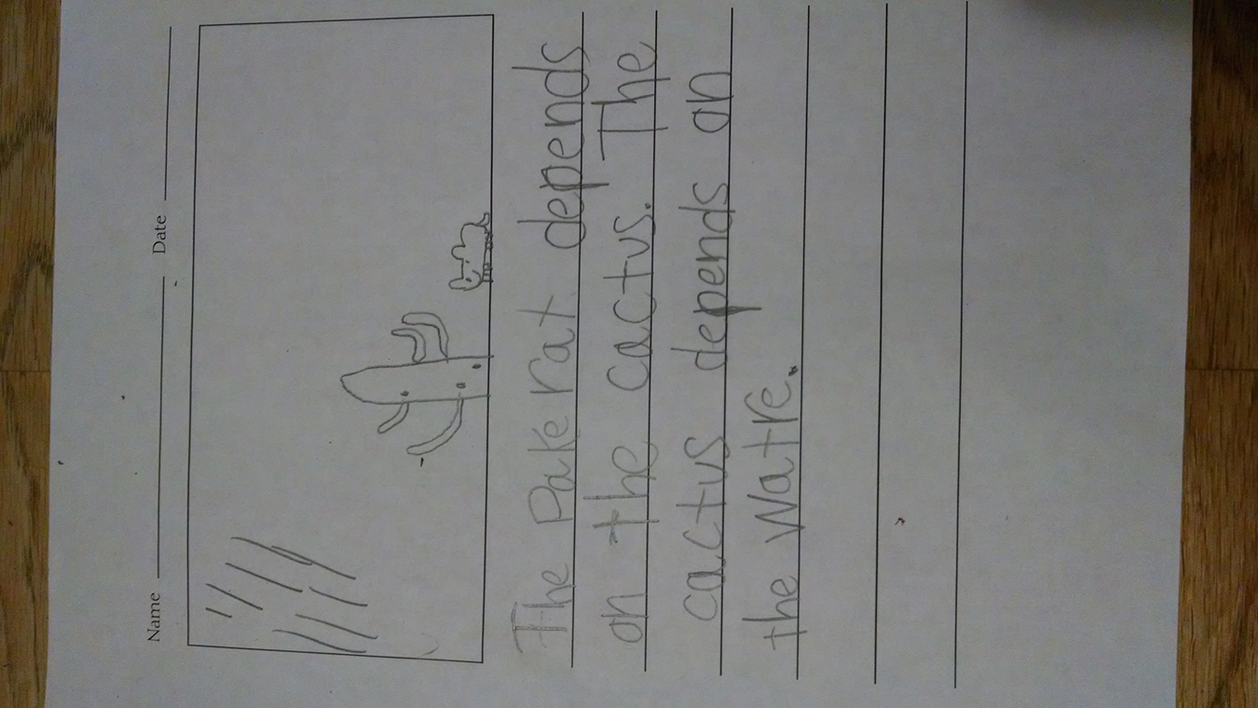

Extension learning activities for this book and other useful resources
- Math for Integrated Unit
-draw a cactus
-add arms
-look closely at the numbers in the book
-how tall? draw another object next to it for scale
p. 8 Cactus is 10 yrs = 4 inches
p. 10 Cactus is 25 yrs = 2 feet
p. 12 Cactus is 50 yrs = 10 feet
p. 18 Cactus is 60 yrs = 18 feet
p. 20 Cactus is 150 yrs = 50 feet
How much does the cactus weigh at age 150 (8 tons – as much as 5 automobiles)
-how much do you weigh?
-trip to parking lot to see how many cars = the weight of the cactus

- In order to reinforce the knowledge and vocabulary that students have learned about the desert habitat, support students by watching an informative video about desert. Note: This is particularly supportive of English Language Learners. Here is an example: https://www.youtube.com/watch?v=gaZKEc59g1w

Note to Teacher
- To lead up to the Culminating Writing Activity, have students write/draw in reading response journal each day. Or add to class chart using the format below if students need a structure. If this is not the beginning of the year, students may write independent sentences.

_________ depends on ________ for __________ Ex. Packrat depends on cactus for food
Depending on level of support needed or time of year this book is used amount of scaffolding and/or independence of students is left up to the teacher. Note: This is particularly supportive of English Language Learners.

What Makes This Read-Aloud Complex?
- Quantitative Measure
Go to http://www.lexile.com/ and enter the title of your read-aloud in the Quick Book Search in the upper right of home page. Most texts will have a Lexile measure in this database.

Most of the texts that we read aloud in K-2 should be in the 2-3 or 4-5 band, more complex than the students can read themselves.
2-3 band 420-820L
4-5 band 740-1010L

700

- Qualitative Features
Consider the four dimensions of text complexity below. For each dimension*, note specific examples from the text that make it more or less complex.

Interdependence – living/non-living things within an ecosystem

Also: Change over time, Impact
Varied sentence length and structures
All page p. 17 - progression of sentence complexity from simple, to compound, then complex. Ex: “The woodpecker gets a weatherproof nest that is shady on hot days and warm and insulated on frosty nights. And the cactus gets something in return: the woodpecker likes to eat the insects that can bring disease to the cactus.”
Verbs are active
Metaphor – Title “Cactus Hotel”
p. 13 “…beckon like a welcoming signal” (simile)
Domain specific language: saguaro, paloverde, Gila woodpecker,

Some students may need background knowledge on what living and non-living things are and plants and animals’ basic needs.
Students may also need to understand a desert.

Meaning/Purpose
Structure

Language
Knowledge Demands

*For more information on the qualitative dimensions of text complexity, visit http://www.achievethecore.org/content/upload/Companion_to_Qualitative_Scale_Features_Explained.pdf

- Reader and Task Considerations
What will challenge my students most in this text? What supports can I provide?
An understanding of basic needs of living things is essential for comprehension.
Questions to clarify how illustrations and text connect.
Tier 2 and 3 vocabulary – picture supports
Varied sentence structures

How will this text help my students build knowledge about the world?
The interdisciplinary concept of interdependence can branch to science, social studies-civics, community, economics, etc.

- Grade level
What grade does this book best belong in? Kindergarten

All content linked to within this resource was free for use when this resource was published in March 2018. Over time, the organizations that manage that external content may move or remove it or change the permissions. If the content is no longer available, please email info@studentsachieve.net.

